**Machine vs Man: An analysis of Formula One Cars and Drivers**

**Task 2**

**A1. Research Question and Organizational Need**

For this study, our research question will be: *“Is the performance of a Formula One car impacted more by the driver's skill or the constructor’s design?”* The driver’s skill in this question refers to the ability of the man or woman behind the wheel. This would include things like reaction time, mental and physical endurance, decision making, and technique. A skilled driver can extract the maximum amount of performance from a car, even if the car is not necessarily the best-performing vehicle. The constructor’s design refers to the engineering and craftsmanship involved in the production of a Formula One car. Factors would include the aerodynamics, engine configuration, and suspension setup of the vehicle. A good constructor produces a car that is capable of great acceleration, speed, maneuverability, grip, and reliability throughout a race. The purpose of this question is to determine if there is a significant difference in impact between the driver and the constructor, and if so, which one is more impactful. This information, if definitive, could be valuable to a team’s decision-making in allocating scarce resources.

**A2. Context and Background**

Formula One is one of the most competitive motorsports in the world. Teams focus their resources on constructing a car that performs efficiently and reliably throughout a race and training a driver with the skill and endurance to win. Formula One is a very expensive sport. The costs for a season run over $100 million. By regulation, each team is given a limited budget for each season to create a level playing field for teams. Before the implementation of the budget, the gap between team spending was quite large. In the 2019 season, the biggest spender, Mercedes, spent around $484 million, while the smallest spender, Haas, spent $173 million (George, 2019). In 2021, the first budget cap of $145 million was applied to all teams and has since been adjusted to account for inflation. The budget cap does not apply to driver salaries. The reason information about the budget cap is included in this paper is to illustrate how much teams spend. The true cost of a Formula One season is deeper than the budget cap demonstrates. Red Bull revealed their 2018 season balance sheet in a Forbes article. As this was before the budget cap, they spent $181.1 million and received $183.6 million in revenue. All are broken down in the following image from the article

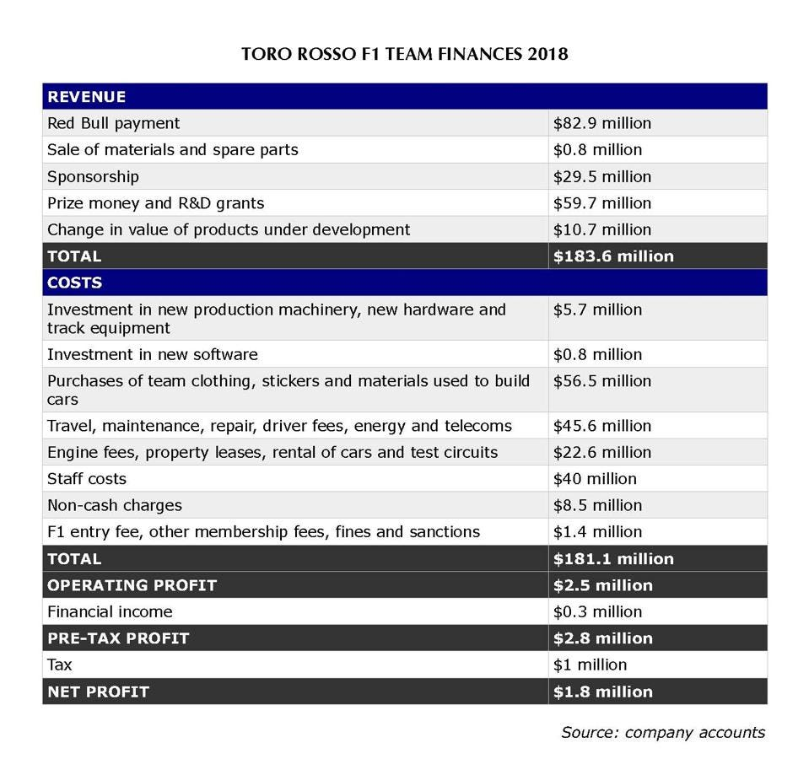

Sylt, C. (2022, October 12). *Red Bull reveals how much it really costs to run an F1 team*. Forbes. [https://www.forbes.com/sites/csylt/2020/01/14/red-bull-reveals-how-much-it-really-costs-to-run-an-f1-team/](https://www.forbes.com/sites/csylt/2020/01/14/red-bull-reveals-how-much-it-really-costs-to-run-an-f1-team/%20)

Formula One has been around since 1950. The sport has continued to evolve over the decades thanks to advancements in technology. Cars have become increasingly computerized and thus more expensive.

**A3. Published Works Summary**

*“Race to the podium: separating and conjoining the car and driver in F1 racing”* by Duane W. Rockerbie and Stephen T. Easton focuses on analyzing financial data with race results from the 2012-2019 Formula One seasons. The authors applied a regression model to each season, combining the driver and team effects. This allowed them to account for season-specific factors. The 80/20 rule had been a prevalent heuristic in the Formula One competitive philosophy. It simply states that 80% of a team’s success odds are placed upon the car and 20% on the driver. The authors challenge the efficacy of this heuristic with their observations. They state that the driver’s role in a team’s success is understated. Rockerbie and Easton state that another impactful factor is the interaction between the driver and the team. We can take the 80/20 rule along with the understanding of the relationship between the driver and the team into our analysis. We can observe if the constructor has such a large impact on the race results.

*“When Success Is Rare and Competitive: Learning from Others’ Success and My Failure at the Speed of Formula One”* by Michael A. Lapré and Candace Cravey examines 21,487 observations (i.e., individual driver race results) from 1950 to 2017. The authors compared the effects of driver errors and car failure on future race results. Essentially, they found that drivers were less likely to learn from their mistakes, vehicle failures boosted the future success rate of a team, and a driver watching a teammate have a successful run improved their chances of success in future races. This is relevant to the investigation of the car’s impact vs the driver because it highlights how teams have historically performed. This study concludes that a team will improve itself more by learning to fix the car than a driver will perform by learning to fix their own mistakes.

*“Formula One Racing: Driver vs. Technology”* by Stephanie Young investigates the reciprocity between driver expertise and advancements in technology.

**A4. Deliverables**

**A5. Analytical Solution**

**B1. Goals, Objectives, Deliverables**

**B2. Scope**

**B3. Project Planning Methodology**

**B4. Timeline**

**B5. Resources and Associated Costs**

**B6. Success Criteria**

**C1. Hypothesis**

**C2. Analytical Methods**

**C3. Tools and Environments**

**C4. Methods and Metrics**

**C5. Practical Significance**

**C6. Tools and Graphical Representations**

**D1. Source of Data**

**D2. Why this Data?**

**D3. Data Collection Methods**

**D4. Observations of the Quality of the Data**

**D5. Data Governance**

**References**

George, D. (2019, December 20). *Amid budget cap for 2021, how much is the current budget of teams in 2019?*. EssentiallySports. [https://www.essentiallysports.com/what-are-the-budgets-for-all-10-formula-one-teams-2019/](https://www.essentiallysports.com/what-are-the-budgets-for-all-10-formula-one-teams-2019/%20)

Sylt, C. (2022, October 12). *Red Bull reveals how much it really costs to run an F1 team*. Forbes. [https://www.forbes.com/sites/csylt/2020/01/14/red-bull-reveals-how-much-it-really-costs-to-run-an-f1-team/](https://www.forbes.com/sites/csylt/2020/01/14/red-bull-reveals-how-much-it-really-costs-to-run-an-f1-team/%20)

Rockerbie, D. W., & Easton, S. T. (2022). Race to the podium: Separating and conjoining the car and driver in F1 Racing. *Applied Economics*, *54*(54), 6272–6285. <https://doi.org/10.1080/00036846.2022.2083068>

Lapré, M. A., & Cravey, C. (2022). When success is rare and competitive: Learning from others’ success and my failure at the speed of Formula One. *Management Science*, *68*(12), 8741–8756. [https://doi.org/10.1287/mnsc.2022.4324](https://doi.org/10.1287/mnsc.2022.4324%20)

Felix-Padilla, I. (2023). A Research Study on Formula One: Determining the Effectiveness of Drivers Based on Their Experience. *Wharton Sports Analytics Journal*. <https://wsb.wharton.upenn.edu/wp-content/uploads/2023/12/Padilla_2023_N.pdf>